Analysis On Imports From Africa(2019-2025)

Project Overview
The imports data represents the Indian trading variation and growth of six years(2019-2015). data have the detailed account of an commodities imports from African countries.Each data have uniquely represent the date,country name Country code,commodity name,regions.others have quantity,dollar,rupees in form of numeric. This project includes phases for data integration and preparation using Power Query, diagnostic analysis and discovery in Excel, and insight generation through power BI visualization.
Project Objective
- Understand the data relationship
To analyze commodities on a country-wise basis using both the Rupee and Dollar.It helps understand the true cost for India import.
- Country-Specific Factors
Analysis must also account for factors unique to the specific trading partner country. These can include trade Quantity and most imports commodities items.
- Collect Necessary data
According the month and year wise to view the India import trends for a particular commodity.and Look for correlations between trade volume/value.
- Regional wise trade
Sub-regional breakdown is crucial for understanding specific trade patterns and dependencies.
- Analyze currency variation on commodity import value
For a commodity imported by India, analyze the international (USD) price and the USD/INR exchange rate separately.
- General analysis framework
Through Power BI will articulate the challenge of consolidating and visualizing this diverse information to derive actionable insights for informed decision-making.

Data Sources
Source Description and Timeline :The data set officially extracted from statistical platform(directorate general of commercial intelligence statistics).and this data set sample get from Indian Data portal.Timeline of the data source is (2015-2024).This project include an visualize for only six years calculations(2019-2025).
Domain : commerce

Problem Statement:International trade analysis

Trade performance evaluation: Analyze trade data to identify top-performing countries and regions based on both quantity and value (USD and INR).

Identify and compare key sourcing countries and commodities:calculate Import value from the top 10 African countries, highlight which countries account for the highest import volumes and values.
regional performance differences:Compare trade performance between regions to see if certain geographical areas consistently outperform others.
Evaluate commodity import patterns by African sub-region:the performance of different African countries as suppliers for specific commodities.
Create metric on Currency volatility: Develop a metric framework that incorporates USD and INR metrics to, focusing on the implications for specific Imports flow and decision-making.
Attributes Details:
Attribute Name | Data Type | Description
ID | Integer | Unique identifier of the data set
Date | Date | Imports trade by date
Country name | Categories | Address the Trade across on-District
alpha3code | Text | character alphabetic and 3 digit Numeric code ISO 3166 codes for each country have District.
Country code | Integer | Code For District name
Country code | String/Text | Name of one country which has districts
Region code | Integer | List out region code in number
Sub region | String/Text | Name of sub-region .
Sub region code | Integer | To Sub-region have related code in integer
Hs code | Integer/string | This Harmonized code for Commodities list out same to all country.
commodity | Categories | Name of Commodities have imported by India
unit | Categories | And this text is unit for commodities
value_qt | Decimals | This is Imports Commodities in term of Quantity
value_rs | Decimals | Total of imported commodities in INR(Rupees)value
value_dl | Decimals | Total of imports commodities in USD(Dollar) value.

Tools & Technologies
Excel : data set transformed through Excel load (ETL) tool power query for data transformation,data consolidation to first process the Shape and clean data by performing changing data types, and handling errors,remove duplicate records, Finally ensuring usable format for Further analysis.
Power BI: Import the data set into Power BI Desktop.Use Power Query to clean and transform the raw data.and ensuring data type consistency to make logical data modelling. To dashboard visuals create a DAX measures for Calculate measure,unique values based on data set.
Data -Processing
Data Consolidation:
In that data set transform10 years into six years through query to following steps sorting and filtering year wise(2019-2025).and formatting all data sets as need.
Data Cleaning:
Power query in excel to identifying and correcting errors,inconsistencies, or missing values in a data set.
Data Consolidation:
data set convert 10 years into six years through query to following steps like sorting and filtering year wise(2019-2025).and formatting all data sets as need.
Data Transformation:
Import data into power bi and transform the data to query and perform
remove blank,rounding the decimal value in column ,check any inconsistency value in data set.

Data Modelling
Data model:
In data modelling date table was created and it have min max date measure value that linked to date field-in calender table.
calender table joined with fact table. It makes visuvals more efficiency.
Cardinal was many to one relationship across fact and calender table.
Next page include this data model.

Calculated Columns & DAX Measures:
used in the DAX (Data Analysis Expressions) formula language to create calculations, measures, and columns for make informed decision analysis and requirement
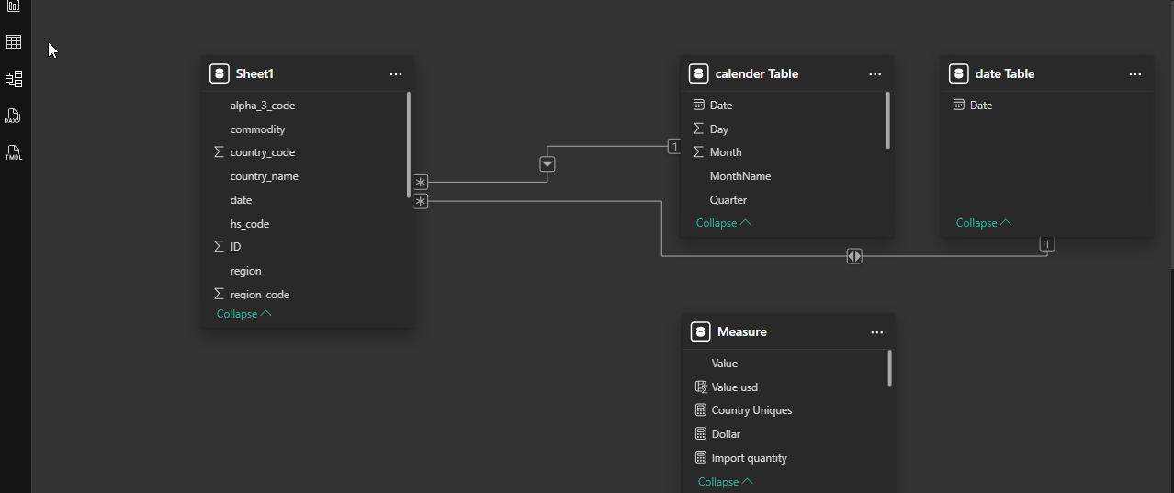

Calculated Function:
- Distinct count
- Total of quantity
- YTD for (Dollars,rupees)
- Top 10 commodities rank
- Total of value region wise
- Total of rupees
- Total of dollars

Analysis and Visualizations (Power BI)
The analysis would aim to identify which African countries and sectors are most exposed to external market volatility. Visually represent the Top primary Commodities in India's total imports from Africa over time. making analysis it refers to data preparation and modeling are uncover patterns and trends ,while visualization is the presentation of that data in interactive ,to easy Under stand the data and effective visuals like bar chart,pie chart,line chart ,etc.
- Develop column chart visuals that compare import performance based on Total Quantity and Sub-region Over Month.
- To analyze trends on Imports trade to show on line chart with measure Total import Rupees and year. Display a line chart tracking total rupees from Africa to India over a Six- year period.
- Year-to-date (YTD) imports from Africa in USD will be visually summarized across a Filled map by color intensity to show the total import value from each country or sub-region. A darker shade indicates higher import value, providing an immediate visual cue for India's most important African trading partners.
- To express Sub-regional trade pattern discovery into Pie chart that distribution based on Total Dollars value.(USD)
- To Variance analysis Create a Stacked area chart that breaks down the total variance in import costs (INR and USD) .
- To use tree maps to show the value of Total quantity.A table can display top-portion country name with detailed import metrics.
- To area chart showing total import value in USD over a specified period (e.g., year) emphasizes the magnitude of changes and total cumulative value over time.
- To evaluate Top 10 commodities along total of USD value in Bar chart.Itwill clearly rank and compare the most significant import products from Africa. Each bar will represent a single commodity (e.g., gold, petroleum, cashew nuts), with its height corresponding to the total import value in USD, allowing for an immediate understanding of which commodities dominate the trade.
- To interactivity include relative date slicer on the overview page showing “Start-End date" is excellent for providing a quick, up-to-date view of import trends.and Drop-down slicer for country Name to specific name need without scrolling through the entire list.
Dashboard

